2016 Club News
October 2016
Presentation Evening & Dinner
On Friday 28th, it was our Presentation Evening and Dinner. Thank you to everyone came and enjoyed the evening. This year it was at The View at Seaford Head Golf Course.
Many thanks to;
Kathy Flood for organising and comparing the event, assisted by Jose Baker.
Betty Landrock for presenting the trophies
Oliver & Sandra Chapman and Jackie Finnie for the raffle
The View staff for a lovely meal and service.
General photos from the evening are below and winners / runners up photos are on the honours page.

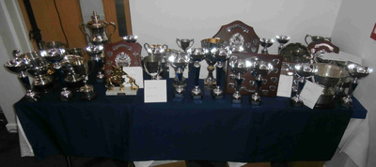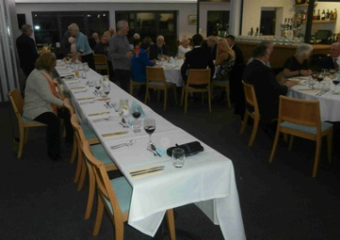

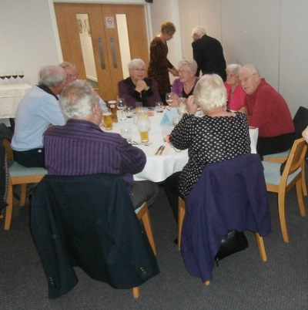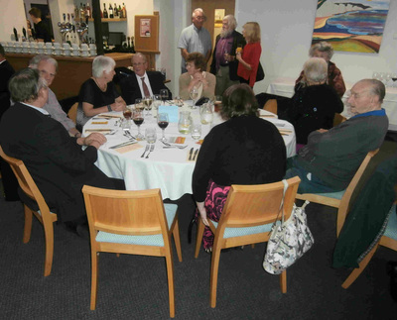

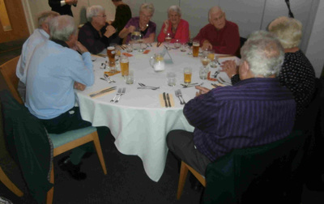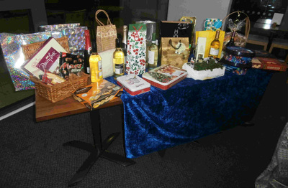

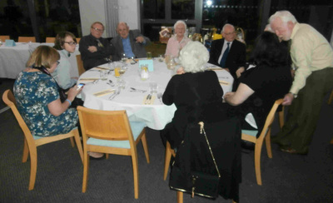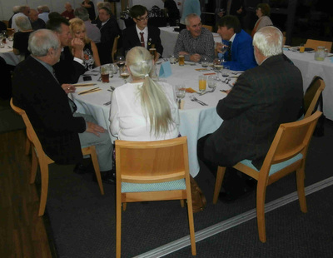

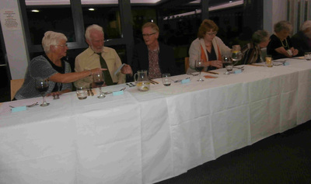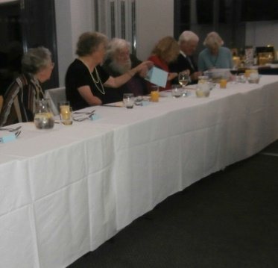

Annual General Meeting
This took place at the Club on October 20th. New committee for the 2016/7 year were elected. See the contact page for details.
Betty Landrock was elected to be the new President after playing for the club for 28 years. She replaced Vic Russell who has been involved for 70 years and is still playing.
Anthony Bradbury continues as chairman and there was thanks given to leaving Treasurer Hazel Bennett. She was presented with gifts as a token of thanks from the club. The post has been taken by Graham Hillman.
Our constitution was ratified and updated after a member consultation. Thanks went to Oliver Chapman for his work on this.
Reports were presented and discussed. The club welcomed new members and thanked Janet Pollitt and Stuart Penfold for their work on this.
After the meeting, a wonderful spread of cheese, biscuits and wine were enjoyed by all.
September 2016
Candlelight Bowls
Well done to the members of the Club who came along to the Candlelight Bowls evening on Tuesday. Every year this event raises money for a worthwhile cause. In 2016 the night raised £159 and the money will be going to PANCREATIC CANCER RESEARCH in memory of Doug Booth,
WINNERS!
Kestrels of Newhaven Bowling Club have won the 2016 Jubilee Cup, played yesterday at Crouch Bowling Club Seaford. The team of Margaret Pellett, Jose Baker, Oliver Chapman & Peter Tyrrell beat Flying Fish of Peacehaven 23 - 16. Well done to all!

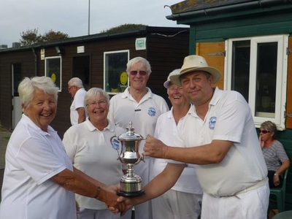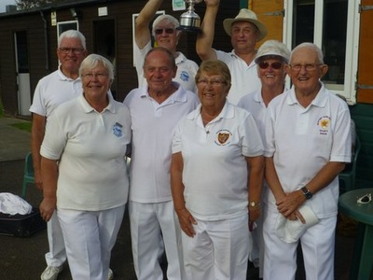

Finals weekend
Results on Fixtures Page.
Congratulations to 3 time winner Sylvia Davies; 2 time winner Graham Hillman, Janet Pollitt, Peter Blackman plus all our other winners including her first Finals Day win for Jackie Finnie. Trophies, pictures and presentations at the Presentation Evening in October.
August 2016
#IAmTeamGB
With the success of Team GB at Rio 2016, as part of our weekly Free taster sessions, we will be joining in the ﻿#IAmTeamGB﻿ day on Saturday August 27th. Juniors can join in from 10am and Adults from 11.30am. Please let us know you are coming using the information on the Join page.
July 2016
From 30th July until the end of the season in September, come along and try bowls every Saturday morning from 11.30am at your local friendly club with the best kept green in the area. Our qualified coach, Janet will be on hand to help all ages and all abilities from beginners to experienced players. All sessions are FREE. Whatever the weather, if you're interested come down to the club to register your interest. Please bring flat shoes, all other equipment is provided. We can be found at in Fort Road, near to the cricket and football grounds
Contact Stuart 07401 663519 or email nbowlscsocialmedia@gmail.com
Competition News
On a rather wet day Alan Burt and Sylvie Davies battled through 3 rounds to reach the 2 wood final in September.
The week before the mixed triples final was decided with K Laverick, S Penfold and J Pollitt to play J Baker, P Feltham and R Houghton in September.
June 2016
Newhaven withdraw from Brighton & Hove Tuesday night league due to a combination of health and other factors.
Bill Voice Trophy Winners 2016
Val Burt, John Moutrey & Tony Bradbury. Well done to all.
Lewes Fixture change - remember we play Lewes at HOME in the Meridian League on Saturday 25th June at 2.00pm.
Denton Community Challenge
Stuart & Helen represented the club at the Community Challenge today. Thanks for you help. They had over 200 kids have a go at target bowls as part of a range of sporting challenges
There was information about the club and were introducing the game to potential new members.
More information about the challenge can be found at this link -
Denton Community Challenge Facebook Page
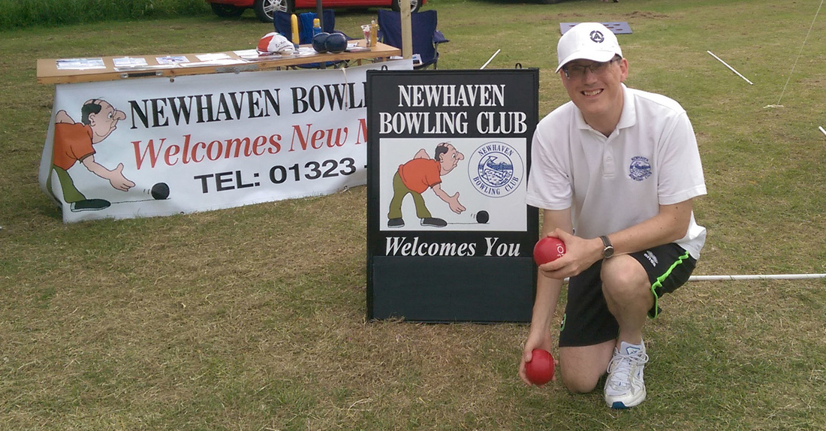
Stuart ready for action at DCC.

Junior Club started on Saturday 4th June with Janet and the team.
New players are welcome to come along if you are under 18. Contact us before on 07401663519. Download the poster for more details (small PDF file).

May 2016
One of the club's members was recognized at the local Newhaven Town Council photographic competition. Stuart Penfold submitted a photo of the touring match, played last summer against Leicester. Against some fantastic photographs, the image was a runner up in the People category. The Town Council announced plans to display the winning photos on banners in West Quay, at an exhibition in France and the possibility of a 2017 calendar. Below is the winning photo and Stuart receiving his prize from Mayor Steve Saunders. The prize is being donated by Stuart to Blind Veterans UK Bike Ride to Paris, which he completed in May.
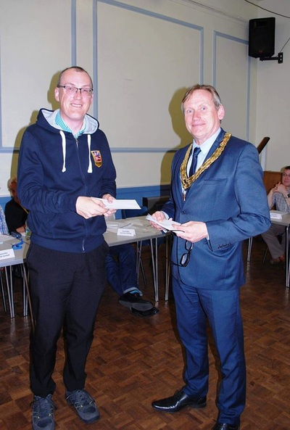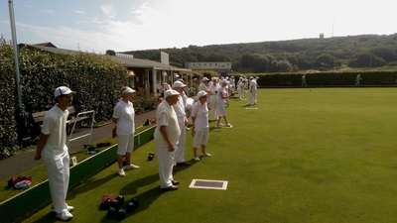

Fixture changes
There has been a number of fixtures changes, the Meridian League games against Lewes have swapped the home & away fixtures. There is also a new friendly which has been arranged with St Dunstan's. The fixture page has been updated.

April 2016
Reminder ! Last social evening at the bowls club on Friday 15th April. Free beetle drive with a fish & chip supper at half time. Fish & Chips £3.70 & Sausage & Chips £2.20. Please let us know if you are coming as soon as possible please as we have to order them from Horaces.
Social evenings will begin again in September. We are changing our nights to Wednesdays. Some of our members bowl at Denton on Friday afternoons so would be happier on Weds. Hope to see you !!
Stuart will be coming round this week with members fixture cards, 2016 membership subscription forms and invite cards for members to give to friends, family and work colleagues. #letsgetbowling
Interested in playing - then call 07401 663519, email nbowlscsocialmedia@gmail.com, contacts us on Facebook or Twitter or use the contact form on the Join page of this website.
February 2016
We played indoors on Friday 19th at Denton Island Indoors Bowls Club. I believe we won last time, but this time it was a score draw.
Result - Phoenix IBC 91 Newhaven 91
This was followed by Peters' Quiz at the club.
Great evening with thanks to Peter Pellett for being quiz master. Team 1 won with 74 points. Well done to Betty Landrock, Margaret Pellett, Stuart and Helen Penfold.
January 1st 2016
Brand New Website
Our brand new website has gone live today. As you have found us the new address for all friends, club members, family and colleagues to follow is www.newhavenbowlingclub.weebly.com.
Don't forget you can find us on;
Twitter - @newhavenbowlsc
Facebook - https://www.facebook.com/Newhaven-Bowling-Club
And all our photographs from last season to date can be found on
Flickr - newhavenbowlspics
Plus 2016 photos on Instagram - newhaven bowling club instagram
Direct links are available on the homepage.

2015 Club News

November 2015 news
26 November
Newhaven Bowling Club held their annual presentation evening at Seaford Golf Course. Attended by over 60 guests, they enjoyed a fantastic 3 course meal. This was followed by the presentation of trophies by our 2015 Chairman and Captain, Anthony Bradbury. Ken Davis and Jose Baker both won 3 titles this year. Full details and photos from the night can be found on the Club Honours page gallery.
16 October
It was with great sadness, we had to announce the passing of past Captain Doug Booth on the 15th October 2015. He was 5 times past captain, ran the Tuesday night men's team, helped out with the Junior Club, organized the tea rotas, a great player and ambassador for bowls in the County. He will be deeply missed by all.
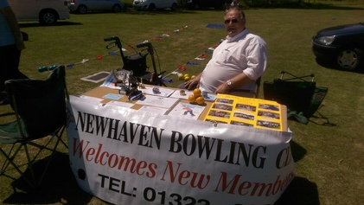
26 September
Our Junior team Have been meeting every Saturday morning through the season.
They play competition bowls as well as target bowls and learning how to mark, the disciplines and rules of the game.
The Junior Presentation morning was on Saturday 26th September.
The top honour of winning the Chris Jarvis Memorial Cup for the most improved bowler of 2015 went to Bradley Page.
For details of the other winners and photos please see the Junior Club page.

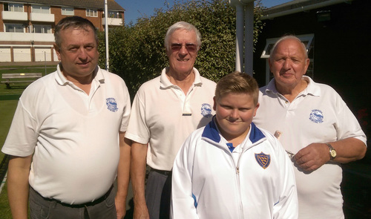

19 September
Bill Hawkins Hot Shot Team
Congratulations to Peter Tyrrell, Bradley Page, Ken Laverick and Oliver Chapman who in the Bill Hawkins Semi Final, Newhaven leg, against Southwick, scored a Hot Shot of 8. Considering that this was the Semi Final (last 4 of 26 teams) this was an astronomic feat rarely seen at this stage of a big competition.
The Bill Hawkins Cup is part of the Brighton & Hove League where each club in the league is allowed one team. There are 26 in all and one leg was played at Newhaven and the other at Southwick. Unfortunately in the end Southwick won by 4 shots but we are very proud of our team who have played well all year with some excellent results. The other half of the team were Ken Davis, Ken Whippy, Luke Gray and Mike Bridges.
Congratulations to Southwick and we wish them good luck in the final.
Newhaven Annual Dinner and Presentation Evening will be at the Seaford Golf Club on Thursday 26th November at 6.30 pm for 7.00 pm sit down. This was a very successful evening last year and we look forward to seeing as many members as possible attend.
Newhaven are in the Semi Final (Last 4 ) of the Bill Hawkins Cup.
This game will be played Home & Away at 10.00 am on Saturday 19th September against Southwick.
Should we be successful the Final will be played at Hollingbury at 2.00 pm Saturday 26th September. Even if we do not make the final spectators will be welcome.
29 & 30 August
Newhaven Finals Weekend
Ken Davis & Jose Baker are triple champions at Newhaven for 2015.
In good weather and fantastic sporting spirit Newhaven held their annual finals on the weekend of 29th & 30th August. Highlights of the weekend include Luke Gray pushing Ken Davis all the way in the Mens Championship. Ken came out the winner
21 - 10 but Luke made him play for every point. Ken needed some very accurate woods to come out the winner. Ken also went on to win the Mens Handicap & 100 Up competitions.
Jose Baker equaled Kens success in the Ladies Championship beating the current Ladies Captain Margaret Pellett in a close match that Jose edged in the final ends. She also went on to win the Mixed 2 wood, and with Peter Blackman won the Partners Competition.
Building on his runners up spot at the county Under 25 final a few weeks ago, Luke Gray 16, won against Peter Pellett in the Mixed Novices.
The youngest member playing, Ross Moutrey, 12, teamed up with Mike Bridges to win the Mens Pairs.It was a family affair as Ross won against his dad, John, & Peter Blackman
For the full results see the Club Honours page.
Passing of Peter Wignall
It is with great sadness that I have to report the passing of Peter Wignall on Monday 24th August. He had been in a nursing home at Seaford for most of this year. He developed a chest infection on Friday 21st August and was admitted to hospital where he passed away. Peter was one of the longest serving members of our club and over the years had held the posts of President, Chairman & Captain. He will be sadly missed. The funeral is at Woodvale, Brighton at 2.30pm Friday 11th September.
There will be a reception at Newhaven Bowls Club afterwards.
Adastra Open Tournament
Congratulations to the team from Newhaven who won the Adastra (Hassocks) Open Tournament recently. The team was Bill Gin, Sylvie Davies, Ken & Liz Davis.
Brighton & Hove League
Congratulations to all the players in the Brighton & Hove League Team.
We had a good season with an excellent start. We ended up with 46 points and the safety in 4th position out of 6 teams. We comfortably stayed in Division 3 for 2016.
Good Results
The outstanding results are beating Crouch twice both at home and away & Mackie in the Meridian League and Preston in the Brighton & Hove League.
Touring Teams
We have welcomed three Touring Teams so far this year, Isle of Wight, Swindon and Coop Leicester. A good time was had by all. We still have two more touring teams to visit us in September.
The Denton Challenge
On the 6th June, Doug, Wendy, Matt Luke and Janet went to the Denton Challenge which is a mix of Sporting Challenges and Summer Fete. We had the wedge set up with some nice brightly coloured Junior Bowls. The was a queue for children and some adults to have a go all afternoon. We also handed out many leaflets to anyone who was interested.

